財務計量經濟學 作業(二)
產經四 林芷瑜s05522042
1.試美國蘋果公司(Apple)從2010/01/01至2020/05/20股價的日資料，並完成下列任務
(A) 計算其日報酬率並繪製其時間趨勢圖。
日報酬率:
apple return
1/02/2020 | NA
1/03/2020 | -0.97696
1/06/2020 | 0.793667
1/07/2020 | -0.47141
1/08/2020 | 1.595817
1/09/2020 | 2.101847
1/10/2020 | 0.225806
1/13/2020 | 2.11394
1/14/2020 | -1.35953
1/15/2020 | -0.42947
1/16/2020 | 1.244865
1/17/2020 | 1.101023
1/21/2020 | -0.68
1/22/2020 | 0.356321
1/23/2020 | 0.480427
1/24/2020 | -0.28862
1/27/2020 | -2.98463
1/28/2020 | 2.789662
1/29/2020 | 2.071625
1/30/2020 | -0.14501
1/31/2020 | -4.53517
2/03/2020 | -0.27501
2/04/2020 | 3.248033
2/05/2020 | 0.812137
2/06/2020 | 1.162901
2/07/2020 | -1.36859
2/10/2020 | 0.473832
2/11/2020 | -0.60516
2/12/2020 | 2.347023
2/13/2020 | -0.71466
2/14/2020 | 0.024628
2/18/2020 | -1.84803
2/19/2020 | 1.437894
2/20/2020 | -1.0312
2/21/2020 | -2.28951
2/24/2020 | -4.86656
2/25/2020 | -3.44591
2/26/2020 | 1.573908
2/27/2020 | -6.76026
2/28/2020 | -0.05852
3/02/2020 | 8.901829
3/03/2020 | -3.22745
3/04/2020 | 4.534097
3/05/2020 | -3.29748
3/06/2020 | -1.3369
3/09/2020 | -8.23953
3/10/2020 | 6.954617
3/11/2020 | -3.53479
3/12/2020 | -10.3978
3/13/2020 | 11.31575
3/16/2020 | -13.7708
3/17/2020 | 4.303085
3/18/2020 | -2.47846
3/19/2020 | -0.76916
3/20/2020 | -6.55903
3/23/2020 | -2.14731
3/24/2020 | 9.560599
3/25/2020 | -0.5524
3/26/2020 | 5.128519
3/27/2020 | -4.22838
3/30/2020 | 2.813838
3/31/2020 | -0.20428
4/01/2020 | -5.40519
4/02/2020 | 1.654901
4/03/2020 | -1.44757
4/06/2020 | 8.364005
4/07/2020 | -1.16499
4/08/2020 | 2.527262
4/09/2020 | 0.719015
4/13/2020 | 1.943753
4/14/2020 | 4.926922
4/15/2020 | -0.91692
4/16/2020 | 0.791434
4/17/2020 | -1.36616
4/20/2020 | -2.09752
4/21/2020 | -3.13982
4/22/2020 | 2.839651
4/23/2020 | -0.38829
4/24/2020 | 2.846075
4/27/2020 | 0.070655
4/28/2020 | -1.63423
4/29/2020 | 3.23174
4/30/2020 | 2.087664
5/01/2020 | -1.62304
5/04/2020 | 1.404963
5/05/2020 | 1.489735
5/06/2020 | 1.026437
5/07/2020 | 1.029176
5/08/2020 | 2.352289
5/11/2020 | 1.561284
5/12/2020 | -1.1494
5/13/2020 | -1.21476
5/14/2020 | 0.61246
5/15/2020 | -0.59296
5/18/2020 | 2.328787
5/19/2020 | -0.57952
5/20/2020 | 1.926146

時間序列圖:
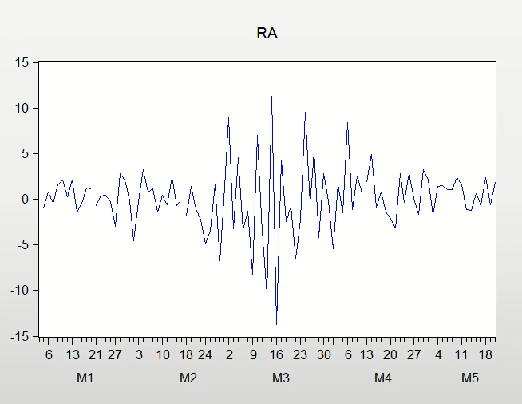

(B) 嘗試建構包含本身報酬率落遲項的迴歸式讓殘差不存在自我相關的問題?
設置殘差前
dotara = apple報酬率變動=當期報酬率-前一期的報酬率
ra = apple當期報酬率（亂設讓模型不準）

Dependent Variable: DOTARA
Method: Least Squares
Date: 05/24/20 Time: 23:35
Sample (adjusted): 1/03/2020 5/19/2020
Included observations: 95 after adjustments
Variable | Coefficient | Std. Error | t-Statistic | Prob.
RA | -1.384513 | 0.095827 | -14.44808 | 0.0000
C | 0.098729 | 0.353017 | 0.279672 | 0.7804
R-squared | 0.691795 | Mean dependent var |  | 0.030559
Adjusted R-squared | 0.688481 | S.D. dependent var |  | 6.164195
S.E. of regression | 3.440478 | Akaike info criterion |  | 5.329926
Sum squared resid | 1100.831 | Schwarz criterion |  | 5.383692
Log likelihood | -251.1715 | Hannan-Quinn criter. |  | 5.351651
F-statistic | 208.7470 | Durbin-Watson stat |  | 1.983640
Prob(F-statistic) | 0.000000

設置殘差後:
Breusch-Godfrey Serial Correlation LM Test:
F-statistic | 2.030518 | Prob. F(10,83) |  | 0.0401
Obs*R-squared | 18.67275 | Prob. Chi-Square(10) |  | 0.0446
Test Equation:
Dependent Variable: RESID
Method: Least Squares
Date: 05/24/20 Time: 22:57
Sample: 1/03/2020 5/19/2020
Included observations: 95
Presample missing value lagged residuals set to zero.
Variable | Coefficient | Std. Error | t-Statistic | Prob.
RA | -0.409268 | 2.881450 | -0.142036 | 0.8874
C | 0.035258 | 0.381600 | 0.092395 | 0.9266
RESID(-1) | 0.582234 | 2.884155 | 0.201873 | 0.8405
RESID(-2) | -0.219428 | 1.113218 | -0.197112 | 0.8442
RESID(-3) | 0.179733 | 0.437944 | 0.410401 | 0.6826
RESID(-4) | -0.113922 | 0.192189 | -0.592761 | 0.5550
RESID(-5) | 0.066142 | 0.118069 | 0.560200 | 0.5769
RESID(-6) | -0.125050 | 0.103016 | -1.213883 | 0.2282
RESID(-7) | 0.192368 | 0.100982 | 1.904980 | 0.0602
RESID(-8) | -0.256589 | 0.101996 | -2.515685 | 0.0138
RESID(-9) | 0.329840 | 0.106071 | 3.109617 | 0.0026
RESID(-10) | -0.100262 | 0.110572 | -0.906755 | 0.3672
R-squared | 0.196555 | Mean dependent var |  | -2.03E-16
Adjusted R-squared | 0.090075 | S.D. dependent var |  | 3.422129
S.E. of regression | 3.264369 | Akaike info criterion |  | 5.321605
Sum squared resid | 884.4567 | Schwarz criterion |  | 5.644200
Log likelihood | -240.7763 | Hannan-Quinn criter. |  | 5.451958
F-statistic | 1.845925 | Durbin-Watson stat |  | 1.985283
Prob(F-statistic) | 0.058991
設到第10期以前的殘差時，聯合檢定的結果0.0401<0.5，模型成立，消除自我相關的問題。

